

**Proposal**

**For**

**Big Data Project**

**School of Computing**

**Customer Transaction Pattern Analysis**

**Submitted by**

**Pema yangchen (12210025)**

**Pema Chozom(12210024)**

**Gyalpozhing College of Information Technology**

**Table of Content**

**Introduction.** **3**

**Problem Definition and Objectives** **3**

Problem Statement 3

Objective 3

**Background and Literature Review** **3**

Background 3

Literature Review 4

**Big Data Source Identification** **6**

Data Sources 6

**Application of Big Data Tools and Techniques** **6**

**Methodology** **6**

**Contextualization and Relevance** **7**

Industry Context 7

Significance 7

**Project Plan** **7**

**References** **8**

# 

# **Introduction:** In today's highly competitive financial environment, understanding consumer behavior is crucial for enhancing service delivery and customer satisfaction. By analyzing customer transaction patterns, financial institutions can improve customer engagement, optimize resource allocation, and make data-driven decisions that lead to better business outcomes.

# **Problem Definition and Objectives**

## **Problem Statement:**

Financial institutions often struggle to understand customer transaction behaviors in a comprehensive manner. This gap in understanding can lead to missed opportunities in targeted marketing, resource allocation, and risk management.

## **Objective:**

* Identify customers with frequent deposit and withdrawal behaviors.
* Determine peak transaction times to optimize service delivery.
* Analyze average customer balance over time to detect trends in financial stability and spending habits.

# **Background and Literature Review**

## **Background:**

Incorporating big data into payment processing has become a transformative force for different organizations across several sectors such as finance, it thus provides significant chances to improve decision-making, streamline processes, and enhance customer experience (Bondarenko, 2023). For instance, big data helps high-risk industries like financial services in combating fraud through its prevention techniques that aid companies in spotting any instances of deceit or malpractice leading to losses reduction by half(Bondarenko, 2023). On the other hand, low-risk firms use broadband internet to simplify transaction handling and raise customers’ participation by up to 25% decrease in transaction time and an increase by 20% respectively (Bondarenko et al., 2023). Additionally, big data plays a crucial role in market analysis by helping businesses identify trends, forecast demand, and refine strategies through insights gained from social media, customer feedback, and web analytics, securing a competitive edge (Comparables.ai, 2024). As the global big data analytics market is projected to reach $68.09 billion by 2025, its impact on driving innovation and strategic decision-making in payment processing and market analysis becomes increasingly critical (Statista, 2023). Incorporating case studies of companies effectively using big data could further illustrate its practical benefits and applications.

## **Literature Review:**

Transaction data analysis is a dramatic tool that gives organizations essential insights into customer behavior, hence promoting optimization of operations and making decisions based on facts. In evaluating such data including purchasing history, transaction value and payment modes among others; firms unveil consumer spending patterns as well as preferences so they may customize their offerings leading to elevated levels of customer satisfaction. Such tools like statistical analysis, machines that learn and visualization of information are important in unveiling these insights which helps businesses in sharpening pricing strategies, cutting down sales barriers or enhancing selling routes. However, while this approach focuses on broader consumer insights, our proposed project goes a step further by specifically analyzing individual customer transaction patterns over time to identify trends such as frequent deposit and withdrawal behavior, peak transaction times, and average balance trends. This targeted analysis will provide financial institutions with deeper, more personalized insights, enabling them to predict customer needs, manage risks, and enhance service delivery in a way that general transaction data analysis may not fully capture (Netscribes, 2024).

Analyzing customer transaction patterns through big data analytics is a crucial aspect of modern business operations, offering insights into consumer behavior that help tailor services and optimize strategies. For instance, the hybrid approach proposed by Wang et al. (2020) integrates multiple big data analytical methods, such as the RFM model and K-means clustering, to effectively segment customers and predict future purchasing behaviors. This method provides businesses with strategic directions for targeting different customer segments and efficiently managing data storage. However, unlike Wang et al.'s focus on broad customer segmentation and future behavior prediction, our proposed project specifically aims to analyze individual customer transaction patterns, focusing on trends like frequent deposit and withdrawal behaviors, peak transaction times, and average balance trends over time. This approach offers more personalized insights, enabling financial institutions to predict customer needs more accurately and manage risks more effectively, which are areas not fully explored by broader customer segmentation techniques (Wang, Tsai, & Ciou, 2020; Netscribes, 2024).

The article "Finding Hidden Customer Behavior Patterns Using Big Data Analytics" discusses the use of behavioral analytics to predict customer reactions and make data-driven decisions, primarily focusing on social media interactions and online activities (Bestarion, 2020). Our project, "Customer Transaction Pattern Analysis," similarly leverages Big Data but concentrates on analyzing financial transaction data to identify trends like deposit and withdrawal behaviors. While both approaches aim to provide actionable insights, our project is distinct in its focus on transactional data, offering financial institutions specific strategies to optimize services and understand customer needs. This comparison highlights the diverse applications of Big Data across different business domains.

The article "The Mission of Big Data in Payments: Magnifying Decision-Making for High-Risk and Low-Risk Businesses" emphasizes how integrating Big Data into payment processing can revolutionize decision-making and risk management for businesses. For high-risk businesses, Big Data aids in risk assessment, compliance, and fraud detection, ensuring operational stability and customer trust. Similarly, low-risk businesses benefit from customer behavior analysis, transaction optimization, and personalized marketing strategies, leading to enhanced customer satisfaction and operational efficiency (Corytech, 2023). Our "Customer Transaction Pattern Analysis" project aligns with these insights by leveraging Big Data to identify and optimize financial transaction behaviors, offering banks data-driven strategies to enhance service delivery and understand customer needs, thereby highlighting the critical role of Big Data across various sectors.

# **Big Data Source Identification**

## **Data Sources:**

* Transaction Logs: These will provide a detailed history of customer transactions, including deposits, withdrawals, and balance checks.
* Financial Databases: Use databases that store historical financial data.
* Real-time Data Streams: If applicable, real-time transaction data can be ingested for up-to-date analysis.

# **Application of Big Data Tools and Techniques**

1. Data Storage and Processing:

* Hadoop HDFS: For storing large volumes of transaction data.
* MapReduce: For processing and analyzing transaction patterns.

2. Data Querying and Processing:

* Hive and Pig: For querying and further processing the data to derive insights.

3. Data Visualization:

* Visualization Tools (e.g., Tableau, Power BI): For visualizing the results and creating reports.

# **Methodology**

1. Frequent Deposit and Withdrawal Analysis:

* Approach: MapReduce will aggregate transaction data by customer ID to identify frequent behaviors.

2. Peak Transaction Time Analysis:

* Approach: Analyze timestamps to determine when most transactions occur.

3. Average Balance Analysis:

* Approach: Use MapReduce to calculate and track the average balance over specific periods.

# **Contextualization and Relevance**

## **Industry Context:** This project is highly relevant to the financial sector, where understanding customer behavior is key to staying competitive. In an era where digital transformation is accelerating, financial institutions are increasingly relying on data-driven insights to adapt to changing market conditions and customer expectations.

## **Significance**:The insights drawn from this project can help improve customer support, enhance operational efficiencies, and enable effective risk management—all of which are critical in a regulated financial environment. By focusing on transaction patterns, this project addresses a pressing need for financial institutions to better anticipate customer needs and respond proactively to emerging risks.

# **Project Plan**

* Timeline: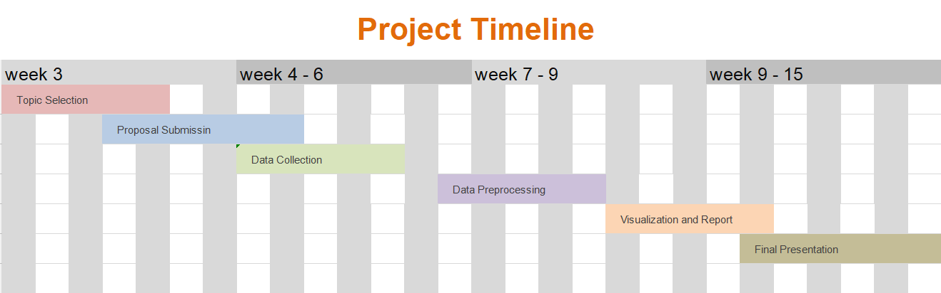

**References**

*Satish, Laika, and Norazah Yusof. “A Review: Big Data Analytics for Enhanced Customer Experiences with Crowd Sourcing.” Procedia Computer Science, vol. 116, Jan. 2017, pp. 274–83. ScienceDirect,* [*https://doi.org/10.1016/j.procs.2017.10.058*](https://doi.org/10.1016/j.procs.2017.10.058)*.*

*Transaction Data Analysis: Extracting Consumer Insights. (2024, June 14). Netscribes.* [*https://www.netscribes.com/extracting-valuable-consumer-insights-from-transaction-data/*](https://www.netscribes.com/extracting-valuable-consumer-insights-from-transaction-data/)

*Wang, S.-C., Tsai, Y.-T., & Ciou, Y.-S. (2020). A hybrid big data analytical approach for analyzing customer patterns through an integrated supply chain network. Journal of Industrial Information Integration, 20, 100177.* [*https://doi.org/10.1016/j.jii.2020.100177*](https://doi.org/10.1016/j.jii.2020.100177)

*Harnessing the Power of Big Data in Payment Processing · Corytech. (n.d.). Retrieved August 21, 2024, from* [*https://corytech.com/payment-insights/big-data-in-payments-decision-making-high-risk-and-low-risk-businesses*](https://corytech.com/payment-insights/big-data-in-payments-decision-making-high-risk-and-low-risk-businesses)

*Finding Hidden Customer Behavior Patterns Using Big Data Analytics—Bestarion. (2020, May 25).* [*https://bestarion.com/finding-hidden-customer-behavior-patterns-using-big-data-analytics/*](https://bestarion.com/finding-hidden-customer-behavior-patterns-using-big-data-analytics/)

*The Role of Big Data in Market Analysis. (n.d.). Retrieved August 21, 2024, from* [*https://www.comparables.ai/articles/role-of-big-data-in-market-analysis*](https://www.comparables.ai/articles/role-of-big-data-in-market-analysis)

Smith, Alivia. *7 Fundamental Steps to Complete a Data Analytics Project*. 2023, <https://blog.dataiku.com/fundamental-steps-data-project-success>.